**Change data capture (CDC) - MySQL to Athena**

(Prepared By: Adinarayana Murthy B, Created: DEC 2023)

**Statement:**

Establish a data pipeline for MySQL database integration into Athena, utilizing a Data Migration Service and Glue job to efficiently ingest data from the source S3 bucket, enabling seamless querying.

**AWS services used in the pipeline**

* S3
* DMS
* Lambda
* Glue
* Athena
* CloudWatch
* IAM

**Architicture:**

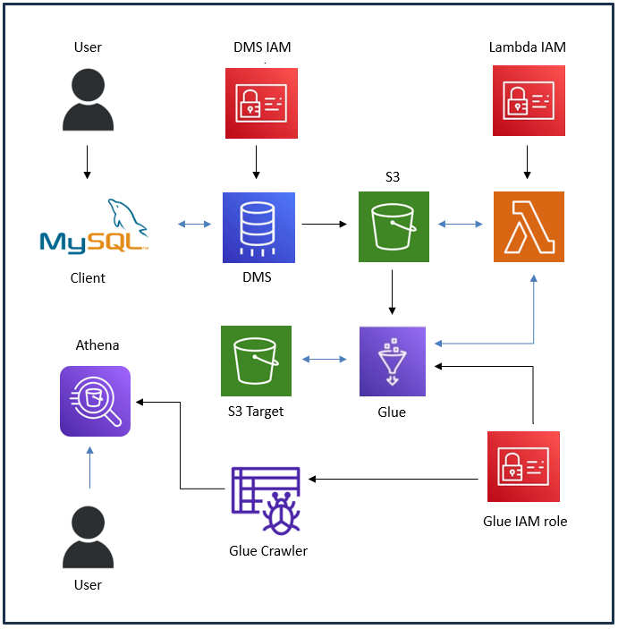

**The pipeline primarily performs the following operation:**

"The data pipeline utilizes the DMS service to extract source data from a MySQL client, transferring it to a staging S3 bucket. A Lambda function detects changes in the staging bucket, triggering a Glue job to move and process the modified data into a target bucket. Subsequently, a crawler is executed to structure the data, making it accessible for querying in Athena."